The Ohio State University

Colleges of the Arts and Sciences New Course Request

Department of Geological Sciences

Academic Unit
Geological Sciences

Book 3 Listing (e.g., Portuguese)
410 Water in the Basin Hydrologic Cycle
Number Title
Basin Hydro Cycle U 05
18-Character Title Abbreviation Level Credit Hours

Summer Autumn Winter X Spring Year 2007
Proposed effective date, choose one quarter and put an “X” after it; and fill in the year. See the OAA curriculum manual for deadlines.

A. Course Offerings Bulletin Information

Follow the instructions in the OAA curriculum manual. If this is a course with decimal subdivisions, then use one New Course Request form for the generic information that will apply to all subdivisions; and use separate forms for each new decimal subdivision, including on each form the information that is unique to that subdivision. If the course offered is less than a quarter or a term, please complete the Flexibly Scheduled/Off Campus/Workshop Request form.

Description (not to exceed 25 words): The occurrence and transfer of water in the hydrologic cycle, common

measurement approaches, and the importance of water in geological processes and as a resource.

Quarter offered: Winter Distribution of class time/contact hours: 3, 1-hr lectures and 1, 3-hr lab/wk
Quarter and contact/class time hours information should be omitted from Book 3 publication (yes or no): No

Prerequisite(s): Geo Sci 100, or Geo Sci 121, or equivalent, or permission of instructor

Exclusion or limiting clause:

Repeatable to a maximum of ___NA__ credit hours.

Cross-listed with:

Grade Option (Please check): Letter X S/U Progress What is course is last in the series? ______

Honors Statement: Yes No X GEC: Yes No X Admission Condition
Off-Campus: Yes No X EM: Yes No X Course: Yes No X

Other General Course Information:
(e.g. “Taught in English.” “Credit does not count toward BSBA degree.”)

B. General Information

Subject Code________________________ Subsidy Level (V, G, T, B, M, D, or P)___________________________
If you have questions, please email Jed Dickhaut at dickhaut.1@osu.edu.

1. Provide the rationale for proposing this course:
See Attached

2. Please list Majors/Minors affected by the creation of this new course. Attach revisions of all affected programs. This course is (check one): Required on major(s)/minor(s) XA choice on major(s)/minors(s)
An elective within major(s)/minor(s) A general elective:

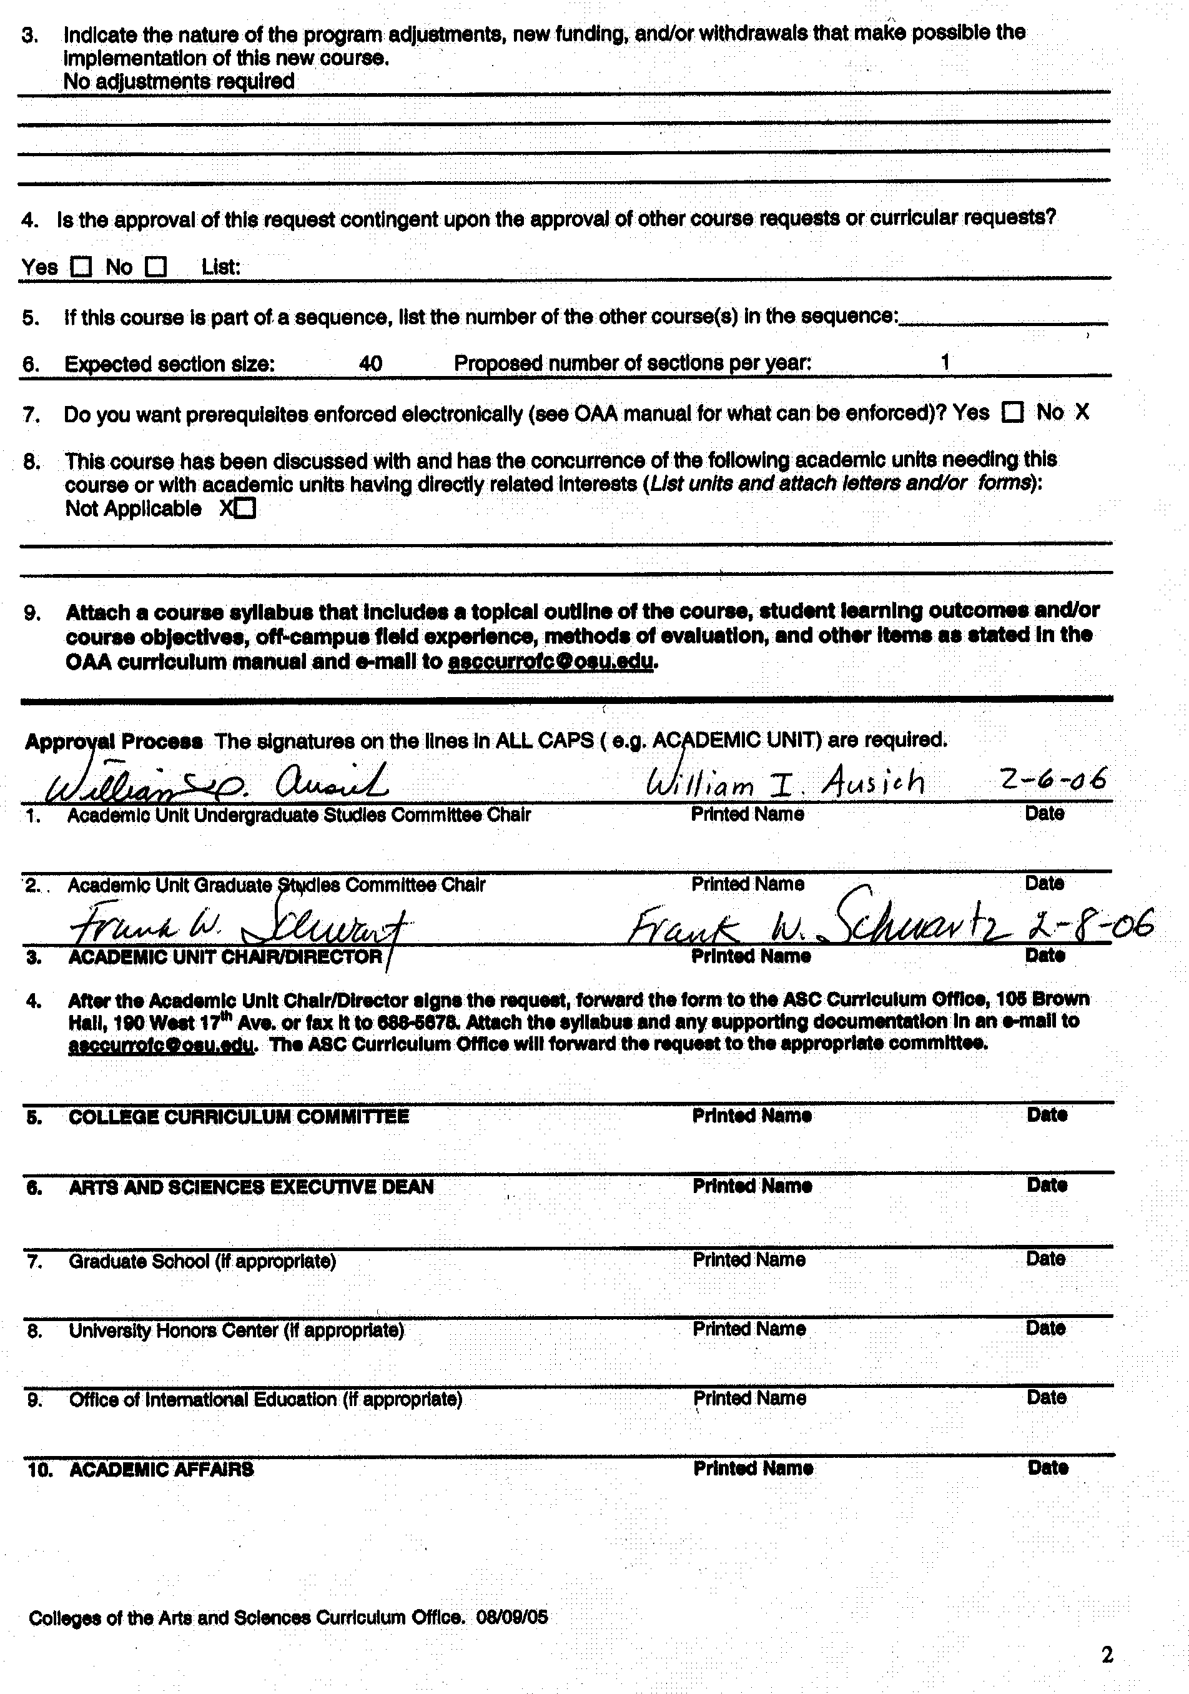

Dept of Geological Sciences 410

Water in the Basin Hydrologic Cycle

Rationale: The hydrologic cycle describes processes and pathways important for redistributing freshwater from the oceans to the continents and back again. It is essential for Earth scientists to (i) understand how water behaves, especially in the land-based portion of the hydrologic cycle, (ii) common measurement approaches to quantify water flows along key pathways, and the volumes of water stored along the way. One reason is that flowing water is important for the geological work that it does, for example, in weathering, erosion, sediment transport, rock formation, and geochemical and biogeochemical cycles.
This undergraduate level course on the hydrological cycle is necessary to provide students with the basic foundation for other courses in the geological sciences as well as more advanced courses in water-related issues. Students outside geological sciences will benefit from this introductory-level course by enhancing their understanding of the occurrence and transfer of water, and its increasingly important role in global human and ecological health, economic, and political issues. It is anticipated that enrollment for this course will grow steadily from less than 10, to 40 or more with increasing departmental and university exposure.

NEW COURSE SYLLABUS

College of the Arts and Sciences
Department of Geological Sciences

Course Number/Title: 410 Water in the Basin Hydrologic Cycle

Instructor/Lectures: Dr. Frank Schwartz

Graduate Teaching Associate: TBD

Required Text/Reading List: Ingebritsen and Sanford, 2006: Groundwater in geologic processes. 2nd Edition, paperback, Cambridge University Press.

Credit: 5 Credit Hours

Prerequisite: Geo Sci 100 or Geo Sci 121, or equivalent, or permission of instructor

Course Structure: Three, 1-hour lecture/demonstration periods and one 3-hour lab/wk

Description: This course explains the occurrence and transfer of water in the hydrologic cycle, common measurement approaches, and the importance of water in geological processes and as a resource.

Content: The course will involve lectures, student discussions, projects, and laboratories. To facilitate discussion and work on projects students will be expected to use time outside of class for readings, studying video presentations, team assignments, and preparation. Students will be expected to participate in local field trips in and around the campus as part of laboratory assignments, and a one-day field trip/exercise early in the term.
Lectures will be highlighted by numerous real-world examples and in-class demonstrations. Laboratories and student projects will develop competencies in the use of common software, like Excel and PowerPoint, and simple hydrologic and hydrogeologic models. We aim to develop the abilities of students to work in teams and undertake specific instruction designed to facilitate these processes. Field exercises will provide opportunities for hands-on measurements of water, sediment, and elemental fluxes, and storage in the hydrologic cycle.

Course Objectives: The primary objectives of this course will be (i) to develop an in depth understanding of the main pathways and processes influencing water in the basin hydrologic cycle, (ii) to develop competencies in making and interpreting measurements describing fluxes and storage within the hydrologic cycle, and (iii) to understand the important role of water in key geological processes and as an essential Earth resource. Secondary objectives of this course will be to develop key student competencies in functioning in self-directed teams, and in the use of common software tools. Overall, the course is designed to provide a foundation for other courses in the geological sciences, and more advanced courses in water-related areas.

Course Grades: The course will be graded according to results from examinations and laboratories, as follows:

Lab Assignments 30%
Team Projects 20%
Final Exam 50%.

Policies on Attendance and Absences: Attendance is required at all lecture sessions. Professor Schwartz should be notified as soon as possible in emergency situations where students must miss class. The deadline for make-up work for missed assignments, quizzes or examinations is one (1) week from the original date of administration. Each student must meet individually with Dr. Schwartz regarding make-up work for missed assignments.

Disability Services: Students with disabilities that have been certified by the Office for Disability Services will be appropriately accommodated, and should inform the instructor as soon as possible of their needs. The Office for Disability Services is located in 150 Pomerene Hall, 1760 Neil Avenue (telephone 292-3307, TDD 292-0901, http://www.ods.ohio-state.edu/).

Academic Misconduct: The Ohio State University and the Committee on Academic Misconduct (COAM) expect that all students will complete all academic and scholarly assignments with fairness and honesty. Failure to follow the rules and guidelines established in the University’s Code of Student Conduct and this syllabus may constitute “Academic Misconduct”.
The Ohio State University’s Code of Student Conduct (Section 3335-23-04) defines academic misconduct as: “Any activity that tends to compromise the academic integrity of the University, or subvert the educational process”. Examples of academic misconduct include (but are not limited to) plagiarism, collusion (unauthorized collaboration), copying the work of another student, and possession of unauthorized materials during an examination. All suspected cases of academic misconduct will be reported to the University Committee on Academic Misconduct. If academic misconduct has been committed, possible sanctions could include a failing grade in this course and suspension or dismissal from the University.

Topical Outline: Here is a tentative outline of major course themes and associated laboratory topics:

1. Course overview; including introduction to the hydrologic cycle, the occurrence of water, the geologic work of water, and fresh-water issues

Laboratory 1.1: Assessment of how freshwater is distributed on Earth, and the basin hydrologic cycle as exemplified by the Mill Creek basin.

2. Introduction to the components of the hydrologic cycle including precipitation, evapotranspiration, ground-water and surface-water runoff, and storage represented by soil moisture, ground-water, etc.

Laboratory 2.1: Application of a simple rainfall/runoff model to simulate the basin hydrologic cycle in the Mill Creek basin, Ohio.

3. Quantitative treatment of hydrologic processes including parameters and processes

4. Technologies for measuring water, and sediment fluxes in the basin cycle

Laboratory 4.1: Stream discharge measurements and USGS streamflow network
Laboratory 4.2: Soil Moisture and water level monitoring in ground water
Laboratory 4.3: Satellite based monitoring of surface-water systems

5. Geologic work of water emphasizing physical and chemical processes like erosion, sediment transport, karst formation, diagenesis, and mineral cycling

Laboratory 5.1: Measuring sediment transport
Team Project 5.2: Student research and presentations on the geologic work of water, and its relationship

6. Water as a resource, emphasizing the uneven distribution of potable freshwater resources, temporal variability related to climate variability and climate change, floods and droughts, and human impacts on water resources.

Laboratory 6.1: Analysis of the water resources of the Scioto River basin with special reference to issues affecting the ground and surface-water resources of Columbus

